Ulvi Bajarani

SID 20539914

CSCI 6345 – Advanced Computer Networks

Summer II

Assignment 6

Ethical Hacking in Kali Linux.

1) The first tool that I used is theHarvester, which gets not only the domain information, but also the emails of domain. Here, the start of help page after execution of **theHarvester -h** to see the help page:

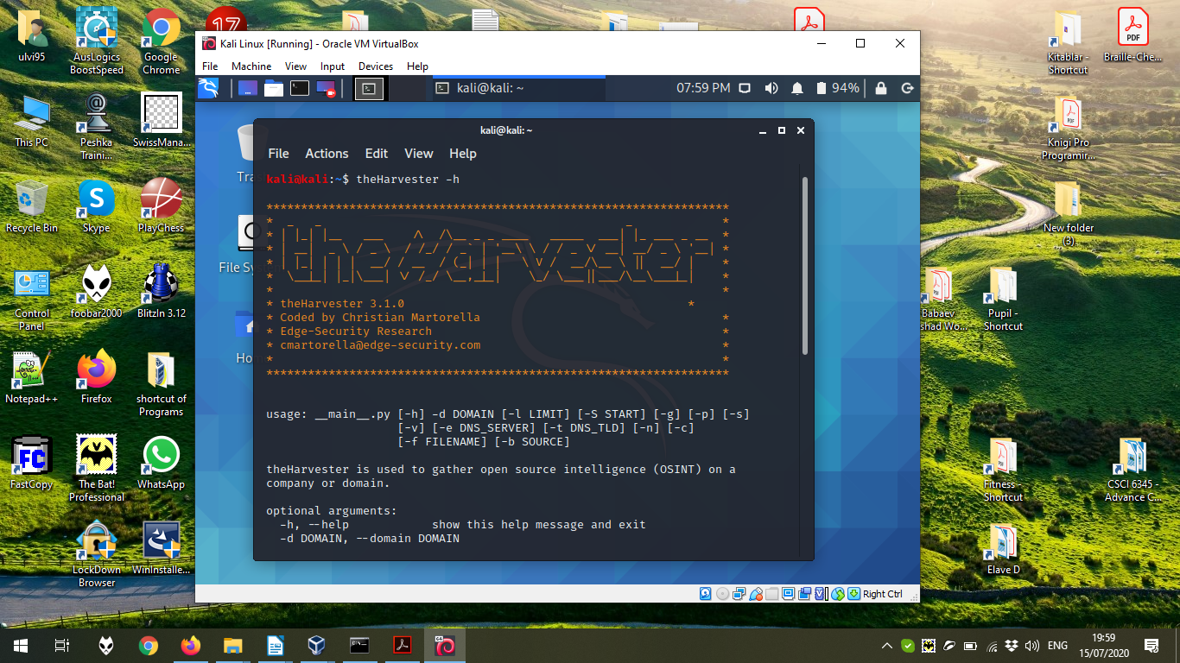

Now, let’s try to execute **theHarvester -d kali.org -b google** command, where, ***-d kali.org*** defines the domain name, ***-b google*** defines the search engine:

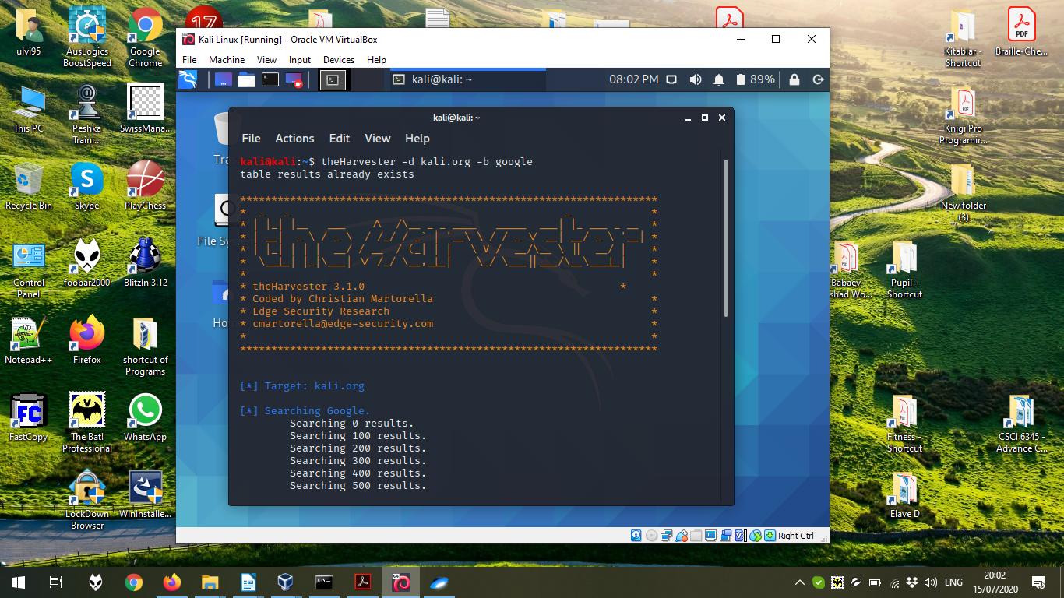

In the bottom, we can see the results:

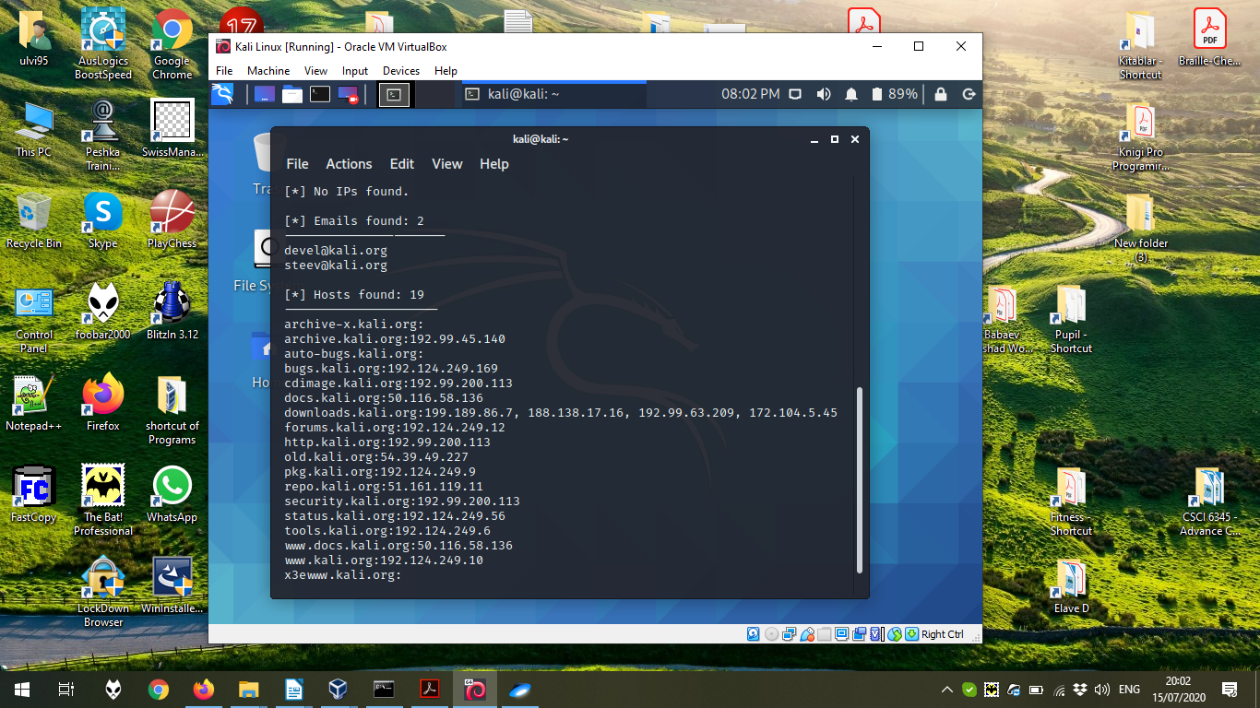

2) Now, let’s try to use more complex program **nmap**, which can retrieve OS, define the ports, find the hosts, configure the search in an UDP port, IPv6 port, etc. Here, the start of help page after execution of **nmap -h** to see the help page:

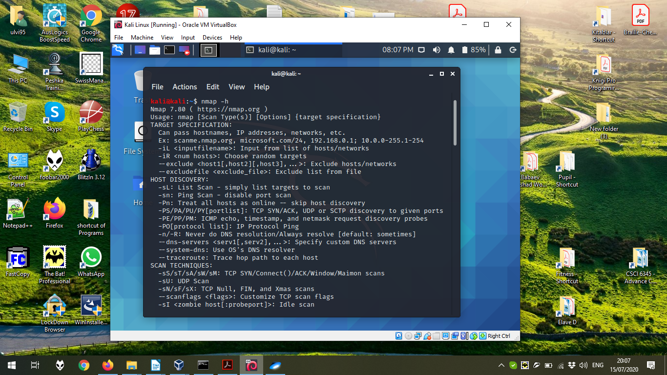

Now, let’s try to execute **nmap -v -A scanme.nmap.org**, where ***-v*** increase the verbosity, ***-A*** is the command to enable OS detection, the version detection, script scanning, and traceroute:

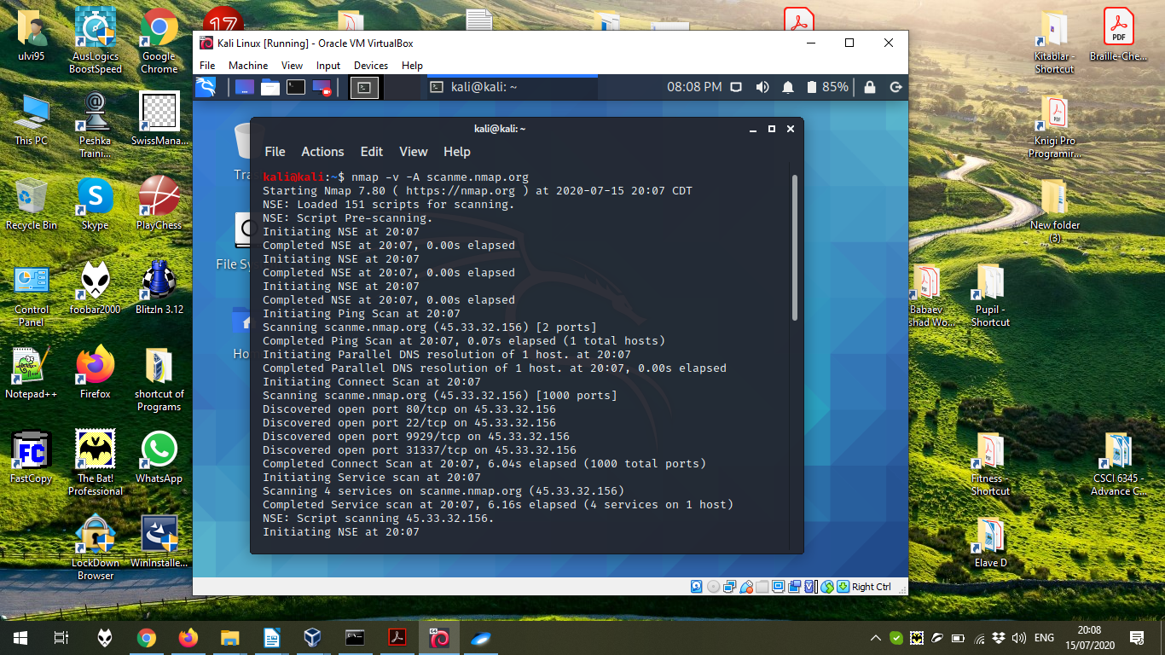

The next page of the execution:

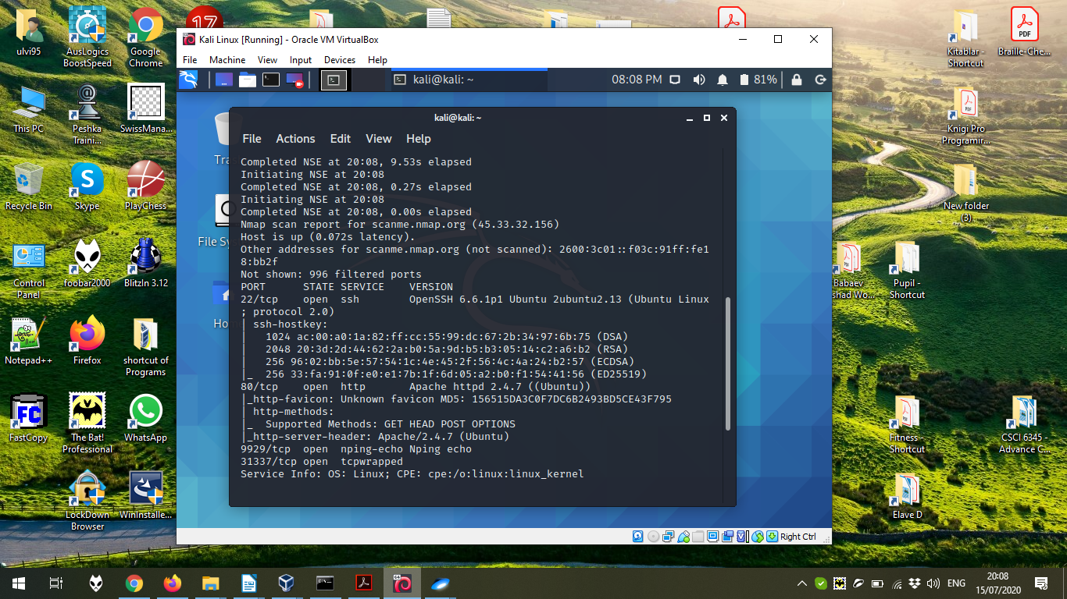

The last page of the execution:

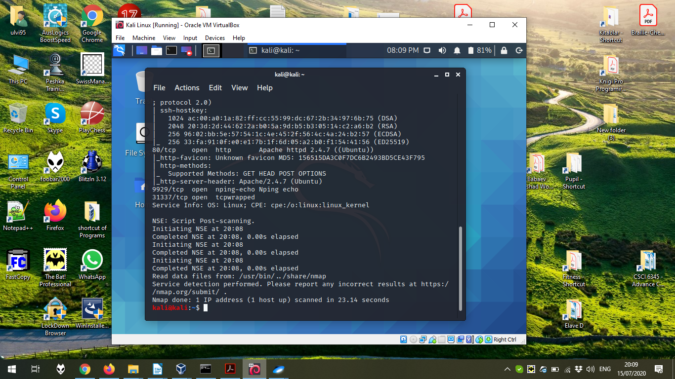

3) It is also possible to use the functions to mask own device. One of them is **macchanger**, which allows to interfere with the MAC address of the device. Here, we can see the execution of **macchanger -h**:

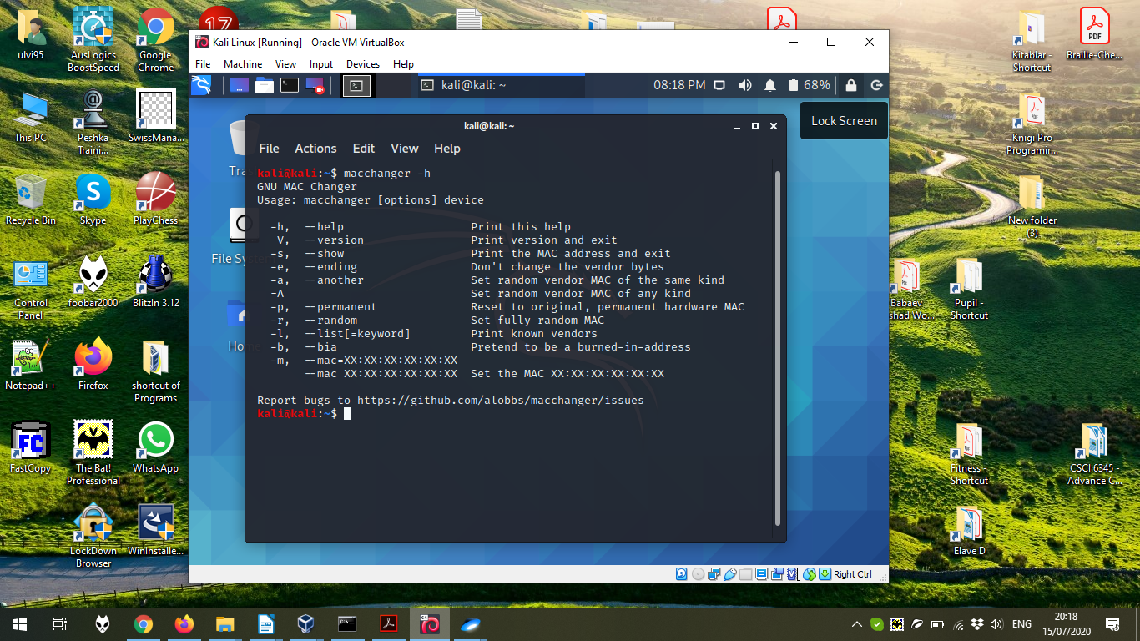

Now, let’s try to change the MAC address of the Ethernet Adapter (eth0) by **sudo macchanger -r eth0**, where ***-r*** stands for the random address. It should be added that by the ***macchanger -l*** command, we can retrieve the list of known devices and their MACs. Here, we just use the random address:

